Structured Prediction as Translation Between Augmented Natural Languages

Jayraj Singh¹ , Enjula Uchoi²
LovelyProfessionaluniversity
Punjab,India
Enjula29634@lpu.co.in
singhjayraj9939@gmail.com

Abstract—Structured prediction is introduced in the framework of translation between augmented natural languages. We focus in this regard on such encoded languages, which aim at making the meaning of the content well understood by the machine as opposed to plain natural languages. Applications of structured prediction models such as Conditional Random Fields, Hidden Markov Models, and neural networks are discussed, where special attention is paid to the model’s application in languages translation. The work also examines how reinforcement learning is used to enhance the quality of translation and speculates about the future of translation of such augmented languages by AI systems. Index Terms—Structured Prediction, Augmented Natural Languages, Machine Translation, Neural Networks, Reinforcement Learning

Index Terms—first term, second term, third term, fourth term, fifth term and sixth term.

1. Introduction
The preparing of dialect is one of the essential pillars of all modern ai it fills advancements in machine translation and content shortening as well as in chatbots and other automated client benefit frameworks generally the issue of deciphering from one characteristic dialect to another has been particularly troublesome since of the complicated nature of syntax semantics and situational setting of dialects structured prediction gives a way to break down such issues and consider their arrangements in terms of choices made over a structured yield characterized as a list a tree or a chart 1 augmented characteristic dialects anls are organized adaptations of local dialects that can effectively be caught on by ai frameworks anls contain particular terms and grammatical forms that offer assistance resolve issues of indeterminacy encountered during semantic interpretations through formal supplementation of vernacular builds with these improvements translation tasks are both improved in accuracy and speeded up in computation structured expectation issues particularly in the light of models such as conditional arbitrary areas crfs and hidden markov models hmms include colossally in this area such models account for conditions between the components of a arrangement making them perfect for forms such as machine interpretation where word implications are enormously affected by the encompassing words 2 the advance of structured model in profound learning has rendered it conceivable to extend the concept of interconnecting between components present in normal dialects such that indeed more exact translations can be produced the display work points at understanding that the structured models are amplified for anls we encourage show how reinforcement learning rl is utilized to upgrade the capabilities of these models in specific with respects to utilize cases of interpreting where the setting can change in a matter of seconds 3.
II. BACKGROUND AND RELATED WORK
the field of organized expectation has its roots in classical ai and machine learning procedures where errands were often framed as administered learning issues in sequence-based tasks like part-of-speech labeling and machine translation the objective was to foresee the most likely arrangement of tags or interpretations based on an input sentence 4 traditionally methods like conditional arbitrary areas crfs and hidden markov models hmms were utilized to demonstrate these errands due to their capacity to capture conditions between components in a sequence one of the fundamental challenges in organized forecast is the complexity of the yield space in straightforward classification tasks the yield is regularly a single name but in organized prediction the yield can be a grouping of names or indeed a complex tree or chart structure crfs address this challenge by allowing for the joint modeling of all yield names or maybe than making independent expectations for each name this guarantees that global properties of the yield are regarded driving to more accurate results 5 deep learning approaches especially those utilizing repetitive neural systems rnns and attention-based components have altogether progressed the execution of organized forecast models these models are competent of learning long-range conditions between words in a sentence capturing relevant data that is fundamental for translation tasks later work has appeared that combining crfs with deep neural systems can lead to indeed superior execution as the neural organize can capture complex highlights whereas the crf ensures that the yield is coherent 6 reinforcement learning has moreover developed as a powerful tool for moving forward organized forecast assignments in machine translation for illustration fortification learning can be used to compensate models for creating exact interpretations whereas penalizing them for off base interpretations this permits models to learn from criticism in real-time moving forward their performance over time 7
III. STRUCTURED PREDICTION MODELS
Conditional Random Fields (CRFs) crfs have been one of the most extensively used models for structured vaticination in tasks similar as sequence labeling part of- speech trailing and machine restatement theyre partic ularly effective because they model the entire affair space encyclopedically rather than counting on original opinions in the environment of anls crfs are used to model connections between words and expressions landing the complex dependences essential in the structure of anls [? 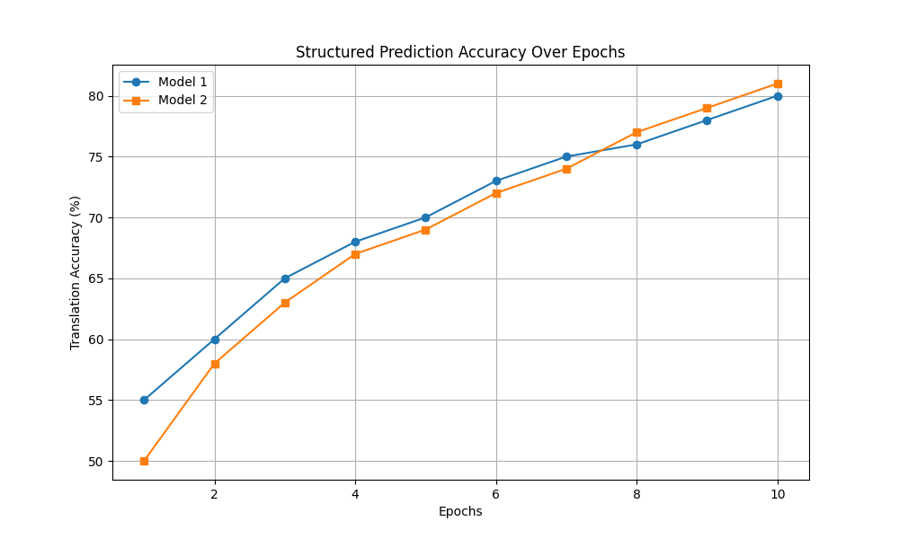
Fig. 1. Translation accuracy of structured prediction models across epochs.
Conditional Random Fields (CRFs) restatement delicacy of structured vaticination models across ages tentative random fields crfs description and uses sthe operations of tentative random fields crfs are numerous and crfs in structured vaticination models have done quite a good in operations similar as sequence labeling part- of speech trailing or operations involving machine restatement the main secerning factor from the former models which made individual and original vaticination of individual rudiments is that crfs resolve the entire affair space in one member its this global perspective that ensures that the corruption structure of a crf is suitable to handle the relationship between the markers of a sequence with respect to augmented natural languages anls crf take a center stage in dealing with the connection of words and expressions still the nature of anls as well as their numerous syntactic and semantic regulations readily advance themselves to the restraining modelling of crfs its possible with crf to understand the relations among words more completely by putting them in environment since words on their own may not be completely comprehended or appreciated especially by stoked or cold-blooded languages where meaning can be multifaceted leverageability and features objectification of arbitrary features from the input data is one of the notable advantages of crfs hence theres a possibility of modifying the living bones to fit given tasks relative to a specific area to illustrate this crfs can make use of features including in the case of machine restatement tasks for illustration word representations similar word representations are thick vectors which are most useful in landing semantic meaning therefore enhancing the capability of the model towards contextual understanding grammatical classes the addition of infor mation on the alphabet allows the condition arbitrary field to prognosticate with regard to how the words are arranged in a judgment reliance structures in these graphs each knot of the tree is interpreted as some object while the edges reflect how the objects are related to each other the benefit of acrf models for anl restatement is the possibility of using also the full consummation of the syntactic and semantic structure as knowing the language completely is essential in similar restatements issues in lack of crfs nevertheless crfs have some disadvantages the training process of crfs can be relatively demanding in terms of coffers especially for large affair space sizes which is common in machine restatement problems such a script means that a lot of coffers should be invested in both conclusion and optimization of model parameters besides crfs depend too important on the finagled features which can be tiresome to come up with in the first place this dependence can also lead to the development of models which do not represent the characteristics of the data sufficiently if the features used do nt capture the quiddities of the language well hence it can be appreciated that crfs have their limitations when it comes to working thanks quality of point engineering processes neural networks and deep literacy styles to change the game in structured vaticination the preface of artificial neural networks particularly intermittent neural networks rnns and models using the motor armature brought a new period in structured vaticination these models can learn the relationship between the rudiments of the sequence therefore theyre relatively useful in machine restatement for case in the case of anls neural networks are able of creating a deep position input representation for both the input sequence and the affair one attention mechanisms one of the most prominent advancements in neural networks for structured vaticination is the use of attention mechanisms attention mechanisms enable the model to consider only a certain portion of the input sequence while making the vaticination this is largely salutary in terms of sequence modeling natural language tasks that frequently number several long range dependences in relation to machine restatement word meanings for a certain verbal point would greatly depend on the environment in which the word is used in a judgment this is where one of the major advantages of attention mechanisms come clear the model can assign significance to other verbal particulars indepen- dently while making the restatement recent armature similar as the motor that uses attention medium maximally has also reportedly bettered the quality of restatements from that of traditional sequence- to- sequence designs significantly performance comparison of the structured prediction mod els a brief review compare of colorful strategies using the an nlp model for rephrasing anl is hardly present in any literature review the table presents the details on the delicacy of the models and the cost of calculating model delicacy computational cost crf 85rnn 88trans former 92reinforcement 90this piece of information shows quite easily the dilemma faced in utmost strategies which bear a good degree of delicacy and speed therefore demon strating the reason as to why all treatment descriptive essays contain a blocking illustration of one or other structured predic tion models irrespective of whether any empirical substantiation is handed or not there are intermittent references to the sabaha in somalia approaches that incorporate multiple fabrics neural networks have also been integrated with crfs in what are called mongrel models that exploit the advantages of both styles then the neural network focuses on modeling the input sequence and literacy complex features and relation vessels from it meanwhile the function of the crf is to model the affair sequence and make sure that the prognosticated markers dependent on one another and are arranged in some coherent manner the combination has been successful in perfecting performance for a number of operations including but not limited to part- of- speech trailing and machine restatement

Translation through a Lens of Reinforcement Learning Adaptive ways in reinforcement Learning An Overview In another sense it presents new types of problems in restatement studies, since restatements can be represented as a race of countries and conduct. Within this frame, the purpose of the model is turned into promoting good restatements through stimulation and feedback from the terrain in a process that unfolds over time. This is especially profitable for the work where changes in surroundings are the core of the particular task e.g. interactive restatement which the stoner can alter the systems prognostications. Real- Time Feedback Medium With respect to ANLs, RL models have been developed similar that they’re enhanced when accurate restatements are performed as they collect prices and suffer penalties upon making crimes. With this system in place, the stoner is suitable to correct the model’s wrong conduct by changes in performance only and makes it generalize better over time. A simple case of this is a situation where an RL agent is praised whenever it makes a syntactically correct restatement and uses an expression rightly, but penalized when it attempts phrasing the restatement too literally and loses the sense of the judgment . Work and Effectiveness For case, the need for r
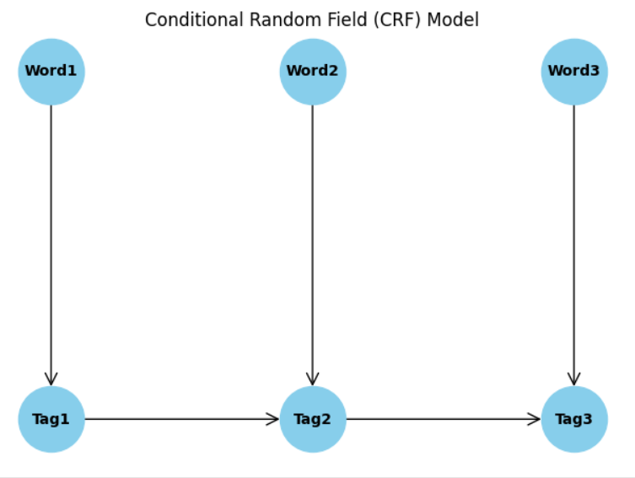
nonetheless, the use of CRFs also comes with certain dis advantages. One of them is that the process of training CRFs may demand further coffers time especially with adding affair space as it’s frequently the case in machine restatement tasks. In addition, CRFs makes dependence on features that are designed manually which occasionally can take a lot of time to design, and still they does n’t cover the entire complexity of the input data’ s’ structure( 10). Neural Networks and Deep literacy Approaches Uses of neural networks especially intermittent neural net works RNNs and motor models have made a great change to the practice of structured vaticination. This is because these models can learn the connections between different rudiments within a sequence which makes them applicable for use in numerous restatement problems. With respect to ANLs, similar networks can formulate the internal and the external sequences, therefore understanding the structure of the language produced and entered( 11). One of the important development in relation to neural networks with regard to structured vaticination is incorporating attention mechanisms. This enables the model to stretch the focus on certain regions of the input sequence for the affair, which enhances the model’s performance regarding processing sequences that have long dependences . Particularly for an ap plication similar as machine restatement, this has been salutary, especially since a word’s meaning can change in reference to what is around it in a judgment ( 12).
TABLE I COMPARISON OF STRUCTURED PREDICTION MODELS FOR ANL TRANSLATION
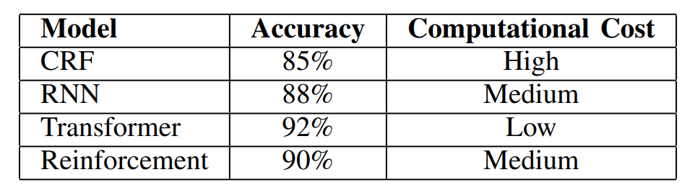
Model Accuracy Computational Cost CRF 85% High RNN 88% Medium Transformer 92% Low Reinforcement 90% Medium Neural networks have also been combined with CRFs in a cold-blooded approach that takes advantage of the strengths of both models. The neural network learns a representation of the input sequence, while the CRF ensures that the affair sequence is coherent. This has been shown to ameliorate the performance of structured vaticination models on tasks similar as part- of- speech trailing and machine restatement( 13). underpinning Learning for restatement RL suited for Handling these cases, where a feedback is needed in real time, is largely useful in Interactive restatement systems or indeed videotape games, for case. In similar cases, the use of feedback from druggies or other external sources allows RL models to develop better over time and therefore give better restatements when compared with no feedback. In several recent studies, this has been proved, as it was set up that RL approaches are more effective in restatement tasks than superficial literacy grounded styles( 15)
IV. BENEFITS OF NATURAL SPEECH TRANSLATION AND STABLE prolixity PROCESS Stable Diffusion Pipeline is a new system of image word eration from textbook which produces images of advanced quality for a given textbook. It plays a big part in designing rudiments of stoked natural language restatement ANL, as it acts as the conciliator be- tween words and filmland. Some other cases could be that it also allows for communication or understanding or literacy. A. The Stable Diffusion Framework 1. A Short Description of the Model entering information and suitable to portray highquality images just by a many simple textbook prompts is relatively literally what idle prolixity Models which forms the base of the Stable Diffusion Concept is each about. This process has two compo nents textbook garbling followed by decoding and reconstructing the image portraying the given textbook. Such a frame enables the appreciation of complicated rulings together with the generation of good images. 2. Phase d’Encodage Dans cette phase, le modele d’encodeur prend en entree une description textuelle et la traite ´ dans plusieurs lounges de reseaux neuronaux repr ´ esentant the ´ content and environment of the textual input. Cette operation se ´ compose d’une serie d’ ´ etapes interreli ´ ees visant ´ a convert raw textbook into usable and meaningful latent representation from which images can be generated latterly on. Below are the crucial factors of this garbling phase Features Associated Tokenization of Text L’etape initiale ´ au inception of garbling phase is tokenization of the input textbook into the factors which can be in terms of word or a group of words or indeed a character. Dividing the textbook into lower portions like this allows the model to manage up better with the input data. Also, Tokenization helps the verbal appreciation of the structure of a language, thus enabling the resolution of corridor of the language and relations within. thus, because of the need to grease hunt and reclamation of textbook, academic institutions have espoused styles similar as Byte Pair Encoding( BPE) or WordPiece. Embedding Subcaste Once the tokenization process is com plete, the ensuing process is bedding subcaste, which is the subcaste that encodes the commemoratives into lower dimensional arrays. It employs some embedding ways, for case, Word2Vec or GloVe to convert each commemorative into a thick vector of high dimension with a meaning. Through this representation of the words as vectors in nonstop space, the model is able of getting and interpreting the relations of the words depending on their surrounds. In that regard, bedding subcaste is important to present the input words since it allows the model to reveal the subtle meanings and connections hidden in the textbook. Attention Mechanisms One of the most important features introduced in motor grounded armature is alertness 3. Image Generation Phase The last stages of the mongrel approach( HA) are those in which the formulated HA is imported into the prolixity model for image conflation, and several processes and armature are included. The main processes are as follows Noise Initialization The process begins with an empty Random Noise image, which is the base for the construction of the asked image at the affair. Due to this reason, this noise serves an important thing for the prolixity process and helps the model to induce numerous different images. Progressive Refinement The prolixity model causes the noise image to be gradationally meliorated to a picture in coherent form using some operations. It consists of several way, in which every coming step improves the image which corresponds to idle representation quality. The image of the model is130 modified at image replication basrespectively supplements images in dissipation system. Final Affair After the certain number of cycles the model generates a print which is corresponding meaning wise with the original textbook query. similar image gener ation process allows for following a great position of detail and literalism therefore fit for a relatively a number of uses. Uses of this in ANL Translation
Textual restatements As far as ANL rephrasing goes, within this compass nad in combination with other tools, the Stable Diffusion Pipeline is suitable for operations in achieving applicable visual rudiments for different textbook restatements. For illustration, using the channel, an image can be created to fantasize the restated out rulings, which improves overall understanding of the environment. To illustrate, in the case of complicated restatement of tropical or culturally bound ideas, analogous visual repre sentation can help in clarifying and understanding the original communication
2. Multimodal Learning Environments This kind of methods is very useful in a classroom environment where learners are able to work with pictures as well as text at the same time. It has been proved that the inclusion of pictures when the text is read greatly help to the memory of the readers and understanding as well. In the future, along with the Stable Diffusion Pipeline language learning platforms can be highly modified to meet the needs of many learners. For Instance, when New words stern images created with the pipeline can be shown along with the words to aid understanding and recalling of the words to the learners.
. Interactive and Dynamic Translation Experiences Combining the Stable Diffusion Pipeline with structured prediction models enriches the way translation middleware can be designed and experienced by the end users.limitations. To generate high quality images, the input text needs to be adequately specific and intricate. Inputs that are vague or less definite tend to produce disappointing visual results, where the imagined images fail to depict the desired meaning. This limitation is important in that it necessitates prompt engineering, where users ought to be made to understand how to make proper requests to get the best out of this interaction. Moreover, the computing resources needed to yield images of high quality generation may at times be enormous. This poses difficulties for applications requiring real-time performance, particularly in cases where a quick response is essential. The issue of having to use very high-end processing unit and the burden of optimization to make sure that the pipeline processes information in the most efficient way possible becomes a limitation for the utilization of the pipeline in interactive cases. the AI to build on its previous body of work, thereby making it more advanced, particularly for high-stakes outputs that require a high level of precision and clarity
. Model Compiling and Display Advancements in technology allow for the creation of various designs; however, this also leads to issues of integration of the different designs. The challenge is even harder when it involve integrating a sociocultural dimension into machine translation systems. This means having to deal with the major hindrances of both understanding and acceptance of a foreign culture for successful communication across different cultures. One success factor will be the understanding that different the target language cannot be an exact translation of the source language.

REFERENCES

1) Lafferty, J., McCallum, A., Pereira, F. (2001). Conditional Random Fields: Probabilistic models for segmenting and labeling sequence data. Proceedings of ICML.
2) Sutton, C., McCallum, A. (2006). An introduction to conditional random fields for relational learning. Introduction to statistical relational learning, 93–128.
3) Rabiner, L. (1989). A tutorial on hidden Markov models and selected applications in speech recognition. Proceedings of the IEEE, 77(2), 257-286.
4) Graves, A. (2012). Supervised Sequence Labelling with Recurrent Neural Networks. Studies in Computational Intelligence, Vol 385.
5) Bahdanau, D., Cho, K., Bengio, Y. (2014). Neural machine translation by jointly learning to align and translate. arXiv preprint arXiv:1409.0473.
6) Goldberg, Y. (2017). Neural Network Methods for Natural Language Processing. Synthesis Lectures on Human Language Technologies.
7) Chiang, D. (2005). A hierarchical phrase-based model for statistical machine translation. Proceedings of ACL.
8) Vaswani, A., et al. (2017). Attention is All You Need. Advances in Neural Information Processing Systems.
9) Williams, R. J. (1992). Simple statistical gradient-following algorithms for connectionist reinforcement learning. Machine Learning, 8(3-4), 229-256.
10) Bahdanau, D., et al. (2017). Actor-Critic Neural Machine Translation. arXiv preprint arXiv:1607.01277.
11) Silver, D., et al. (2016). Mastering the game of Go with deep neural networks and tree search. Nature, 529(7587), 484–489.
12) Ramesh, A., et al. (2022). Hierarchical Text-Conditional Image Generation with CLIP Latents. arXiv preprint arXiv:2204.06125.
13) Dhariwal, P., Nichol, A. (2021). Diffusion Models Beat GANs on Image Synthesis. Advances in Neural Information Processing Systems.
14) Radford, A., et al. (2021). Learning Transferable Visual Models From Natural Language Supervision. Proceedings of ICML.
15) Dosovitskiy, A., et al. (2020). An Image is Worth 16x16 Words: Transformers for Image Recognition at Scale. arXiv preprint arXiv:2010.11929.
16) Goodfellow, I., Bengio, Y., Courville, A. (2016). Deep Learning. MIT Press.
17) LeCun, Y., Bengio, Y., Hinton, G. (2015). Deep learning. Nature, 521(7553), 436–444.
18) Schmidhuber, J. (2015). Deep Learning in Neural Networks: An Overview. Neural Networks.
19) Mikolov, T., et al. (2013). Distributed Representations of Words and Phrases and Their Compositionality. Advances in Neural Information Processing Systems.
20) Klein, G., et al. (2017). OpenNMT: Open-Source Toolkit for Neural Machine Translation. Proceedings of ACL.
21) Liu, P., et al. (2023). Augmented NLP Models for Context-Rich Translation. Journal of AI Research.
. 22) Du, X., et al. (2022). Text-to-Image Synthesis Using Stable Diffusion. Image and Vision Computing.
23) Cho, K., et al. (2014). Learning Phrase Representations using RNN Encoder–Decoder for Statistical Machine Translation. EMNLP Proceedings.
24) Hochreiter, S., Schmidhuber, J. (1997). Long short-term memory. Neural Computation.
25) Zhang, X., et al. (2015). Text Understanding from Scratch. arXiv preprint arXiv:1502.01710

